**HQ Site**

**Domain Controller 1: HQ-DC01**

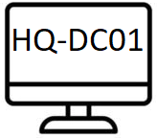Uses: Windows Server 2022

Roles: Active Directory

Authoritative DNS for Int.Elections.bc.ca

Authoritative DHCP (Load-Balanced)

Location: 326-012 POD 1 (Bottom-Row 4th)

Switch: External

Ipv4: 10.10.20.1

**Domain Controller 2: HQ-DC02**

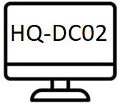Uses: Windows Server 2022

Roles: Active Directory

Secondary DNS For int.elections.bc.ca

Authoritative DHCP (Load-Balanced)

Location: (326-011 POD 1 Bottom-Row 3rd)

Switch: External

Ipv4: 10.10.20.2

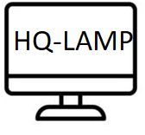**Lamp Server: HQ-LAMP01**

Uses: Ubuntu Server 22.04 LTS

Roles: Inside DMZ

Location: (326-010 POD 1 Bottom-Row 2nd)

Switch: External

Ipv4:

**Domain File Services (DFS01): HQ-DFS01**

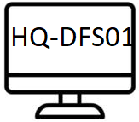Uses: Windows Server 2022

Roles: DFS Namespaces

DFS Replication

Location: 326-010 POD 1 (Bottom 4th)

Ipv4: 10.10.20.4

**Domain File Services (DFS02): HQ-DFS02**

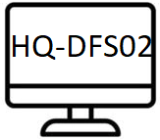Uses: Windows Server 2022

Roles: DFS Namespaces

DFS Replication

Location: 326-011 POD 1 (Bottom-Row 3rd)

Switch: External

Ipv4: 10.10.20.5

**Headquarters Firewall: HQ-FW01**

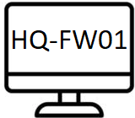Uses:

Roles:

Location: 326-009 POD 1 (Bottom-1st)

Switch: External, External 2

Ipv4:

**Voting Site Firewall: VS1-FW01**

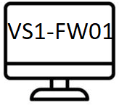Uses:

Roles:

Location: 326-005 POD 2 (Top 1st)

Switch: External, External 2

Ipv4:

**Domain Controller: VS1-DC03**

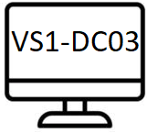Uses: Windows Server 2022

Roles: Active Directory

Secondary DNS For int.elections.bc.ca

Location: 326-007 POD 2 (Top 2nd)

Switch: External

Ipv4:

**Domain File Services (DFS03): VS1-DFS04**

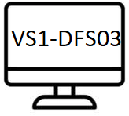Uses:

Roles:

Location: 326-007 POD 2 (Top 2nd)

Switch: External

Ipv4:

**Domain Controller: VS1-DC04**

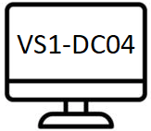Uses:

Roles:

Location: 326-007 POD 2 (Top 2nd)

Switch: External

Ipv4:

Domain File Services (DFS04): VS1-DFS04

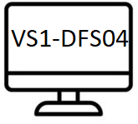Uses:

Roles:

Location: 326-007 POD 2 (Top 2nd)

Switch: External

Ipv4: